Business process mapping template
This template supports the National Artificial Intelligence Centre’s guidance on how to prepare your business.
- Map your processes
Table 1. Process details
Process name
Date mapped
Process owner
Mapped by

Table 2. Process steps
Step | Action | Who | Inputs | Outputs | Time
1
2

Table 3. Pain points
Step | Issue type | Description
1
2

- Identify opportunities
Table 4. Assess AI fit
Pain point | Volume  (1–5) | Repetitive  (1–5) | Data  (1–5) | Error Tol  (1–5) | Cost  (1–5) | Total score  (AI fit)

Table 5. Priority ranking
Priority level | Pain points
Priority AI opportunities
(high AI fit + high impact)
Quick wins
(high AI fit + low impact)
Process improvement first
(low AI fit)

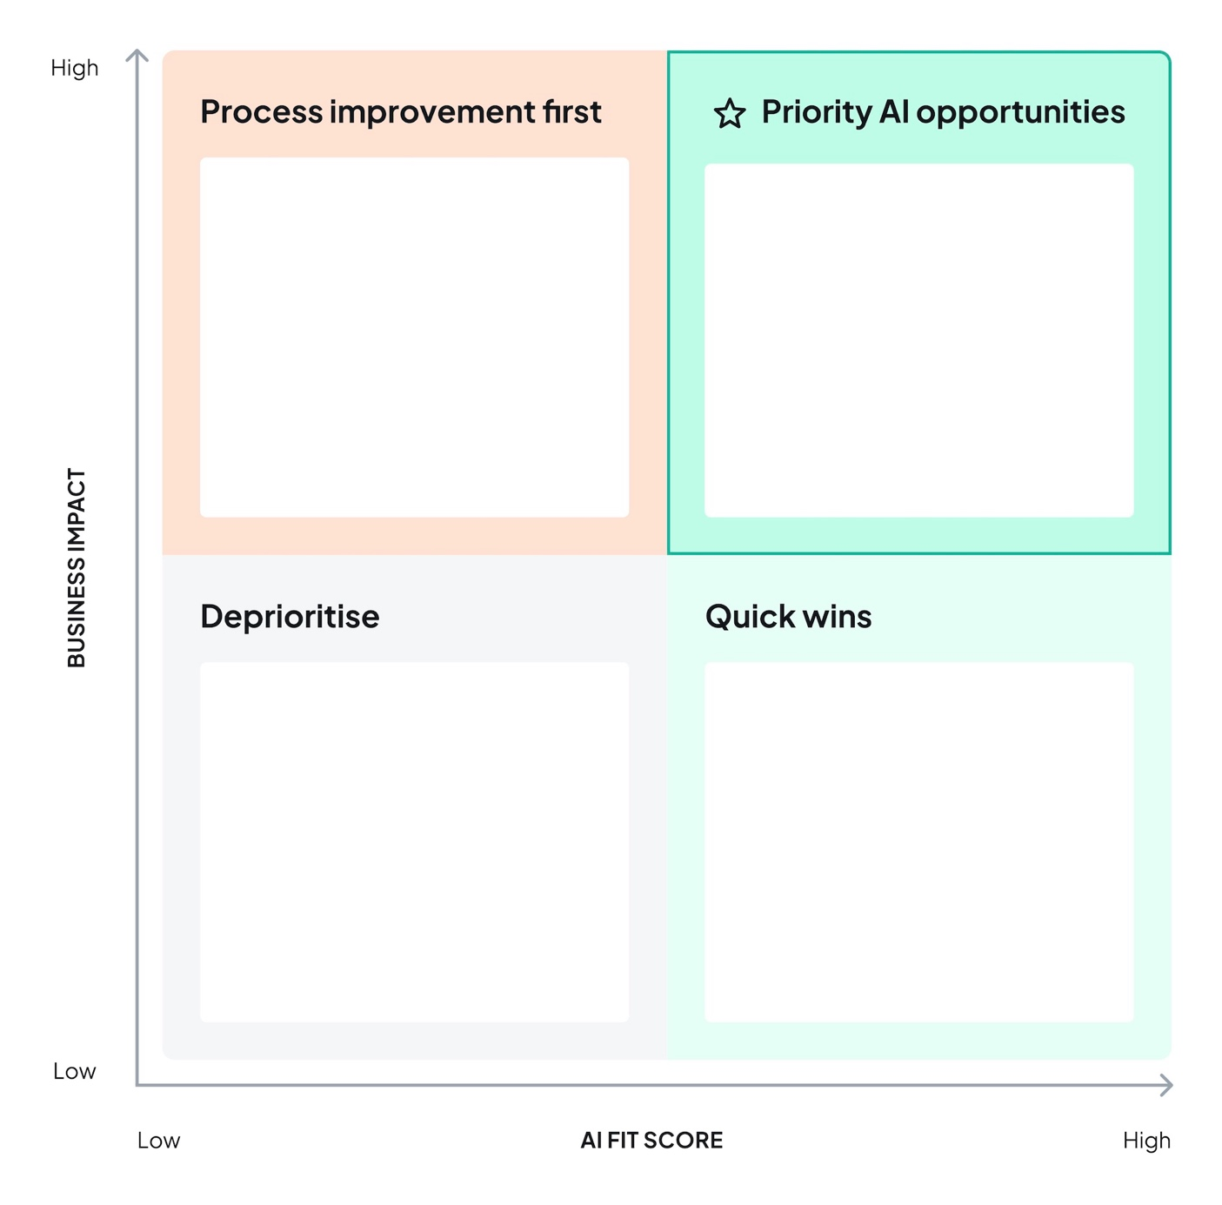
Add tasks here
Add tasks here
Add tasks here
Add tasks here
Figure 1. AI opportunity assessment matrix

- Redesign your workflow
Table 6. Workflow design
Process name
Current state
Target state
Expected benefits

Table 7. Task division
Task | AI responsibility | Person responsibility | Oversight pattern

